

**MCTE 2332 PROJECT**

**TITLE: DIGITALDISPLAY OF PLACE IN MOSQUE LEFT**

**NAME: MUHAMMAD IMRAN BIN MARDZUKI**

**MATRIC NUMBER: 1918179**

**1. Goal of the project.**

For this project, we are assigned to construct a working system based on what we have learned in digital system design topic. I have decided to make a counter that will show many places left in the mosque during performing congressional prayer. During this pandemic time, we are required to make a distance between people at least one meter. Because of this, the number of people that can perform the congressional prayer in one row(saf) is limited. For mosque in my region, one row only can be used by only 7 people. The counter that I will make will display at the outside of the praying space the number of people used the row for every row. So this will make it easier for the newest people that coming to mosque to performing congressional prayer to know how many place left inside the mosque.

**2. Design process.**

The design of this project starts with data acquiring. To acquire the data of the number people using the row, the detector will detect the people when there is a person at the place in the row. The people need to enter the place in the row according to the order. The first person will have to take the place at the middle of row. After that, the row must be fill from the right of the first person and then left of the first person accordingly just like illustrated below:

|  |  |  |  |  |  |  |
| --- | --- | --- | --- | --- | --- | --- |
| 7 | 5 | 3 | 1 | 2 | 4 | 6 |

The detector will be placed based on the number illustrated above. As example the detector will only detect 3 people if they are at the place 1, 2 and 3. The next step is to convert the data we acquired to the binary number. In this step, the logic gate will be used, so the truth table and the Karnaugh map(k map) is required in this step. After that, the binary number will be used to light up the digital signage(7 segment display) that will show the number of people use the row. For this step also. The logic gate will be used. As the 7-segment display have 7 input, we have to convert 3 bits binary input to 7 output to light every segment according to the number. The 7-segment display is as below:

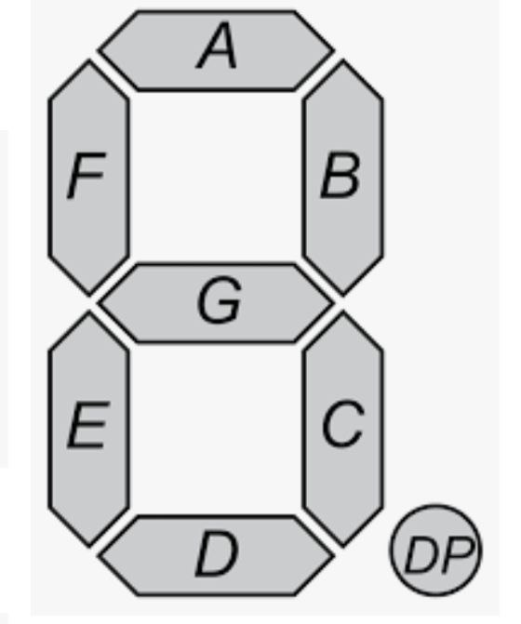

So, if the number of people is 1, the output of B and C must be high, and the others must be low to show the number 1. The simplification of the design process:

1. Data acquisition.
2. Convert data to 3 bits binary number.
3. Binary number to 7 output( connected to 7-segment display).

**3. Detailed design.**

1. Data acquisition.

The input data is from the number of people that used the place in one row. 1 row have 7 places to perform prayer, so 7 input must be acquired.

1. Convert data to 3bits binary number.

The requirement of this process is truth table and the observation from the truth table. Since we have 7 input, it is too hard to use Karnaugh map. The truth table contain 7 input and 3 output (x,y,z from lsb to msb):

|  |  |  |  |  |  |  |  |  |  |  |
| --- | --- | --- | --- | --- | --- | --- | --- | --- | --- | --- |
| No | Input | | | | | | | Output | | |
|  | I1 | I2 | I3 | I4 | I5 | I6 | I7 | x | y | z |
| 0 | 0 | 0 | 0 | 0 | 0 | 0 | 0 | 0 | 0 | 0 |
| 1 | 1 | 0 | 0 | 0 | 0 | 0 | 0 | 0 | 0 | 1 |
| 2 | 1 | 1 | 0 | 0 | 0 | 0 | 0 | 0 | 1 | 0 |
| 3 | 1 | 1 | 1 | 0 | 0 | 0 | 0 | 0 | 1 | 1 |
| 4 | 1 | 1 | 1 | 1 | 0 | 0 | 0 | 1 | 0 | 0 |
| 5 | 1 | 1 | 1 | 1 | 1 | 0 | 0 | 1 | 0 | 1 |
| 6 | 1 | 1 | 1 | 1 | 1 | 1 | 0 | 1 | 1 | 0 |
| 7 | 1 | 1 | 1 | 1 | 1 | 1 | 1 | 1 | 1 | 1 |

To form a Boolean expression, the truth table must be observed for every output. The observation is like below:

* Output z

Output z will be high if one of the pair of odd and even is high or the i7 is high. The Boolean expression is:

Z= (i1 ⊕ i2) + (i3 ⊕ i4) + (i5 ⊕ i6) + i7

* Output y

Output y will be high if pair of pair of odd and even is high. The simplification of the Boolean expression is:

Y= (i2 ⊕ i4) + i6

* Output z

Output z will be high start from i4 is high. Boolean expression is:

Z=i4

The circuit got from those Boolean expression:

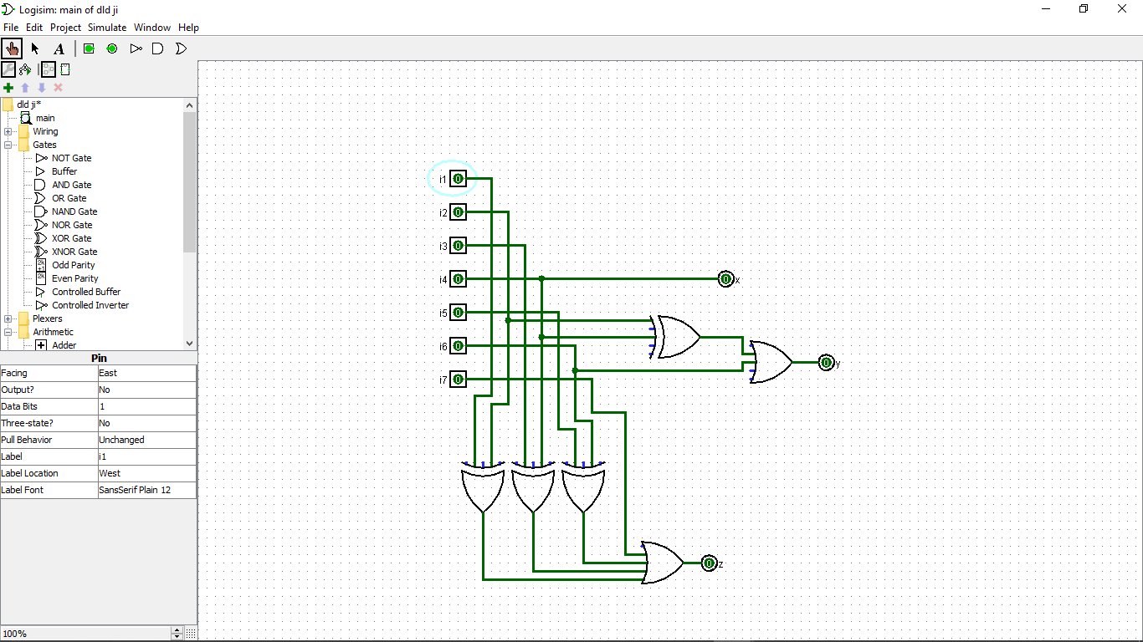

1. Binary to seven output.

The output that wanted from binary number is 7 output which is a, b, c, d, e, f and g. the output represent:

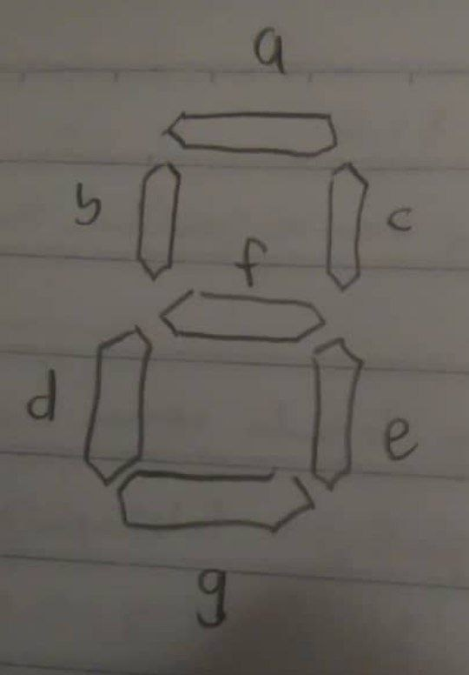

As the desired output want to display the number of people and the binary number represent the number oh people, we get the truth table:

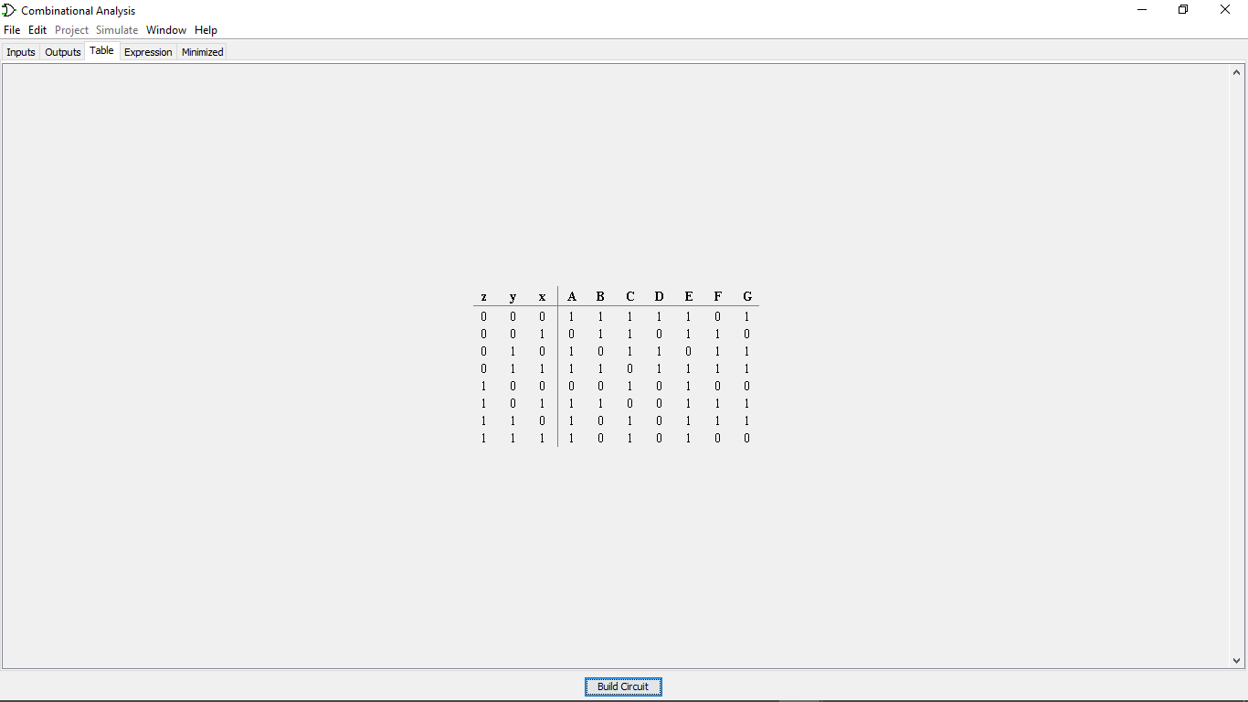

To get the Boolean expression, the Karnaugh map is required:

* Output a

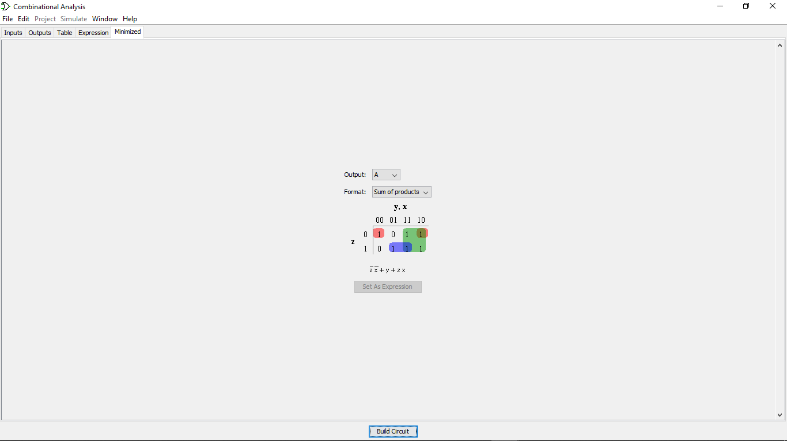

* Output b

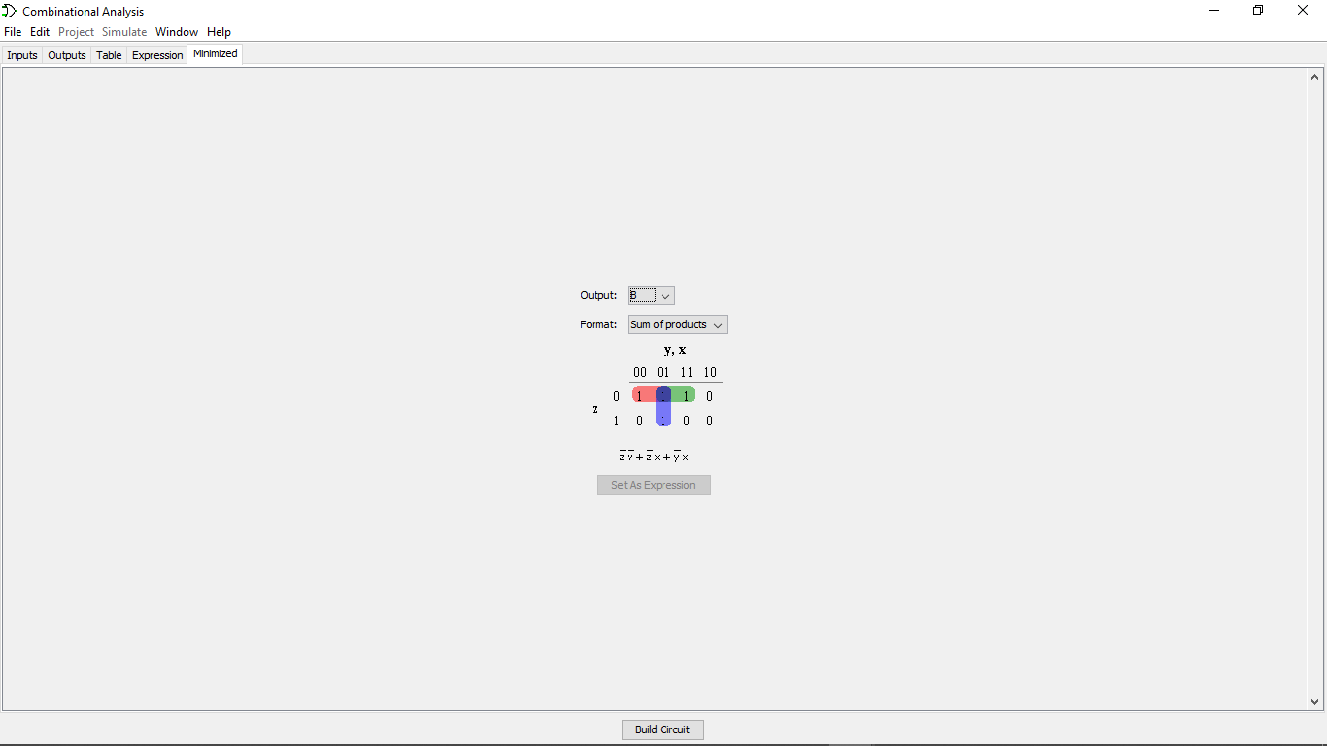

* Output c

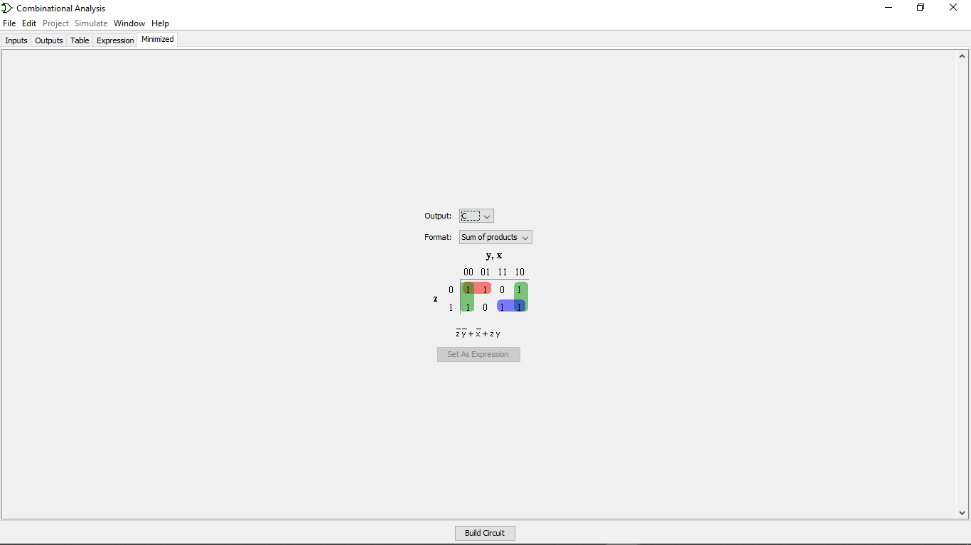

* Output d

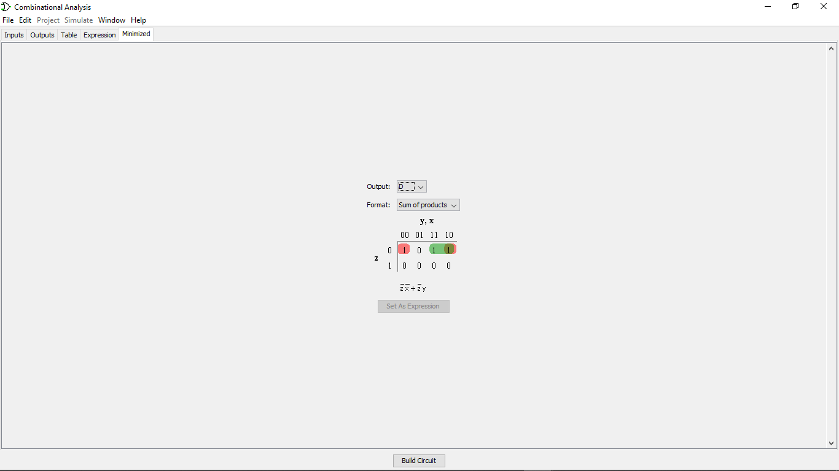

* Output e

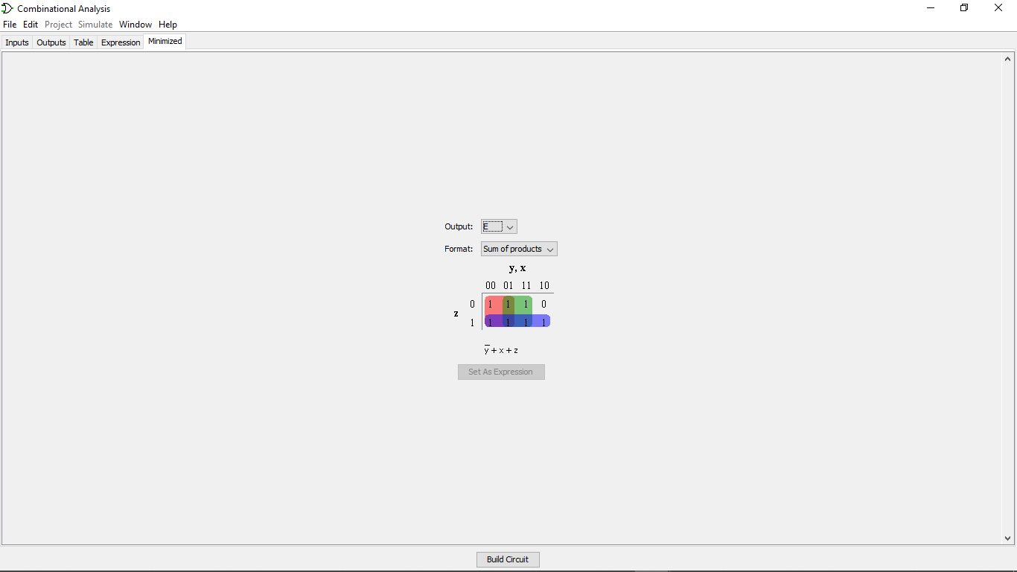

* Output f

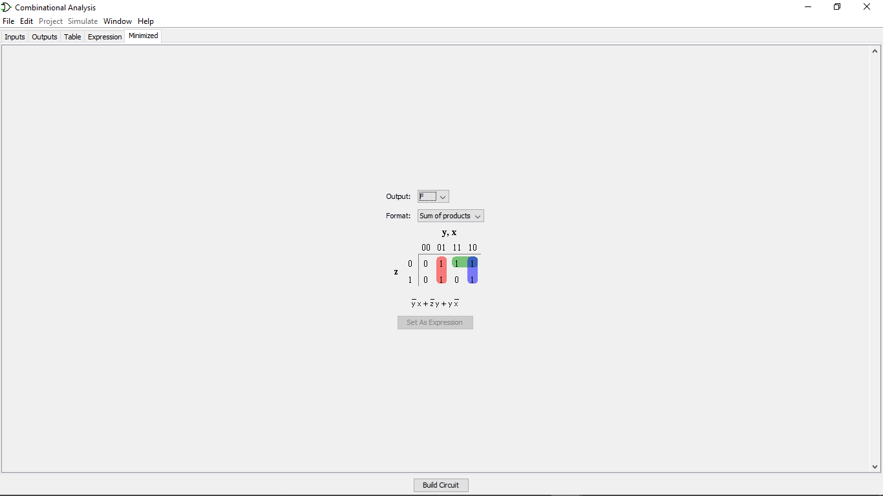

* Output g

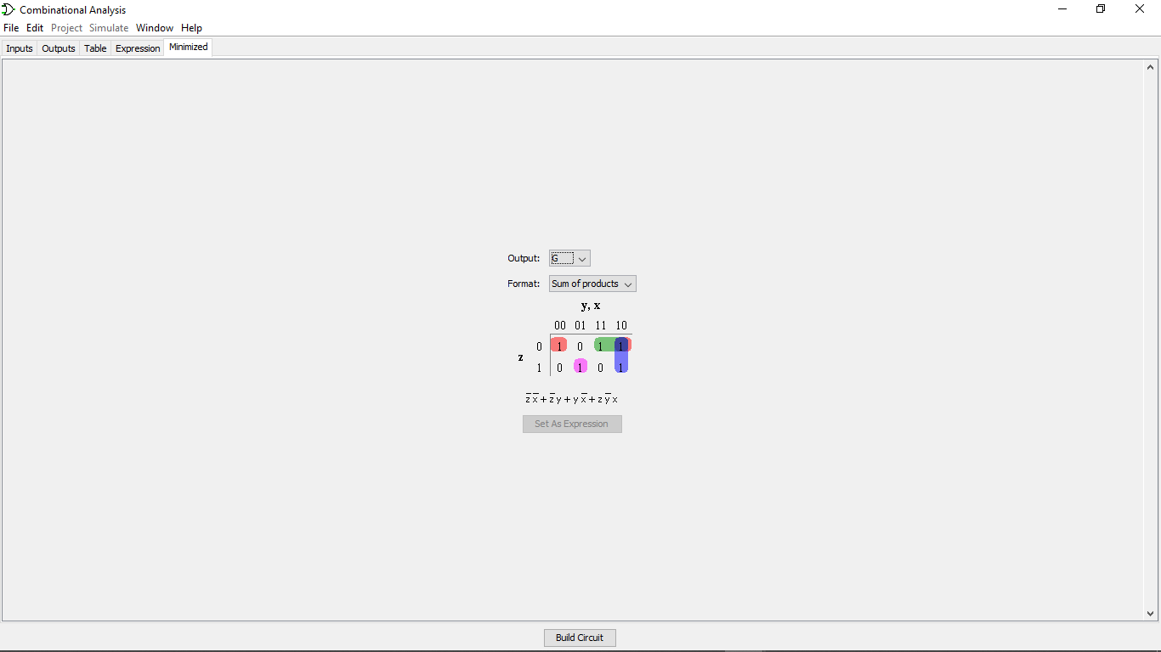

The circuit got from the Boolean expression:

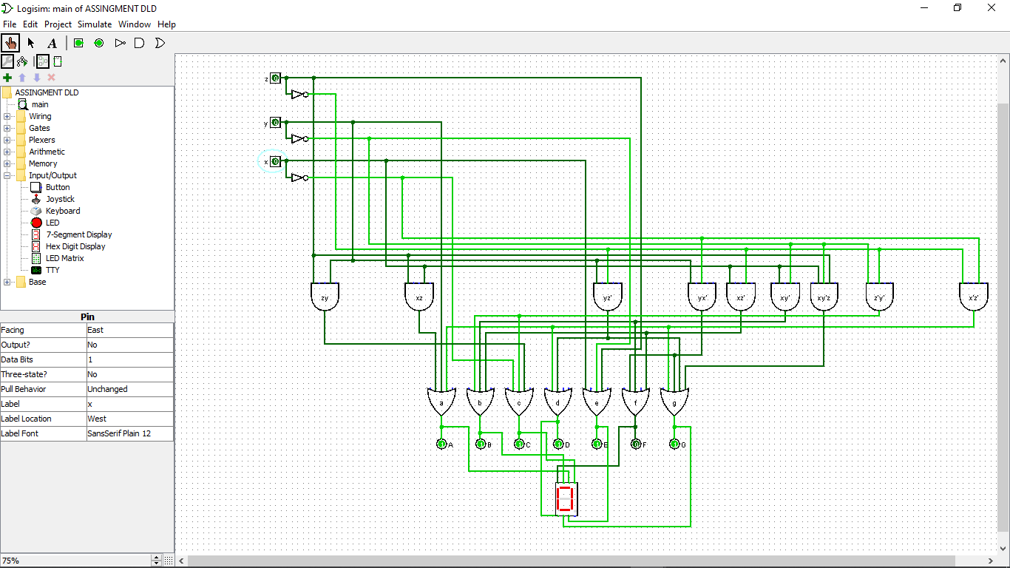

**4. Design verification.**

For the verification, the Logisim is used to show all the input and output of the design to verify it:

1. 1 people.

When there is 1 people, only i1 will be high. The output for 3 bits binary is x=0, y=0 and z=1. For the output of 7-segment display, a=0, b=0, c=1, d=0, e=1, f=0 and g=0 to form 1. The verification using Logisim is as below:

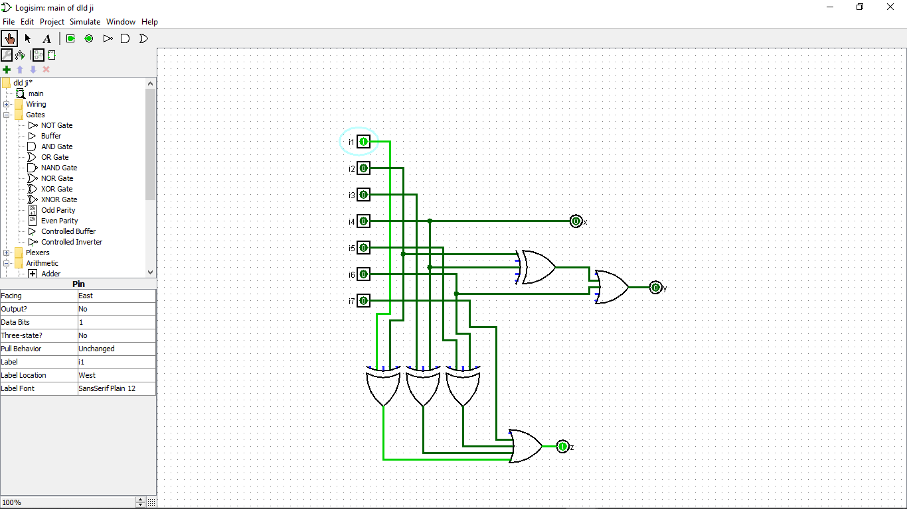

Only z=1 when there is 1 people.

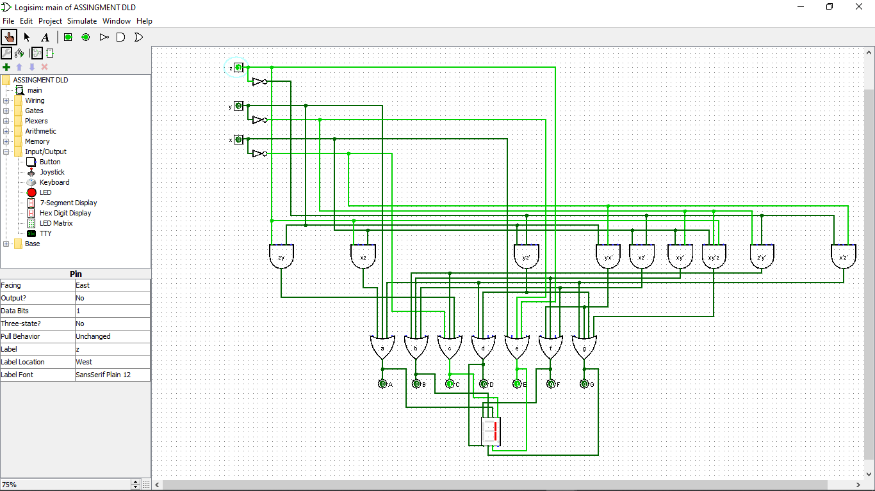

c and d high and digital signage display number 1

1. 2 peoples.

When there is 2 people, i1 and i2 will be high. The output for 3 bits binary is x=0, y=1 and z=0. For the output of 7-segment display, a=1, b=0, c=1, d=1, e=0, f=1 and g=1 to form 2. The verification using Logisim is as below:

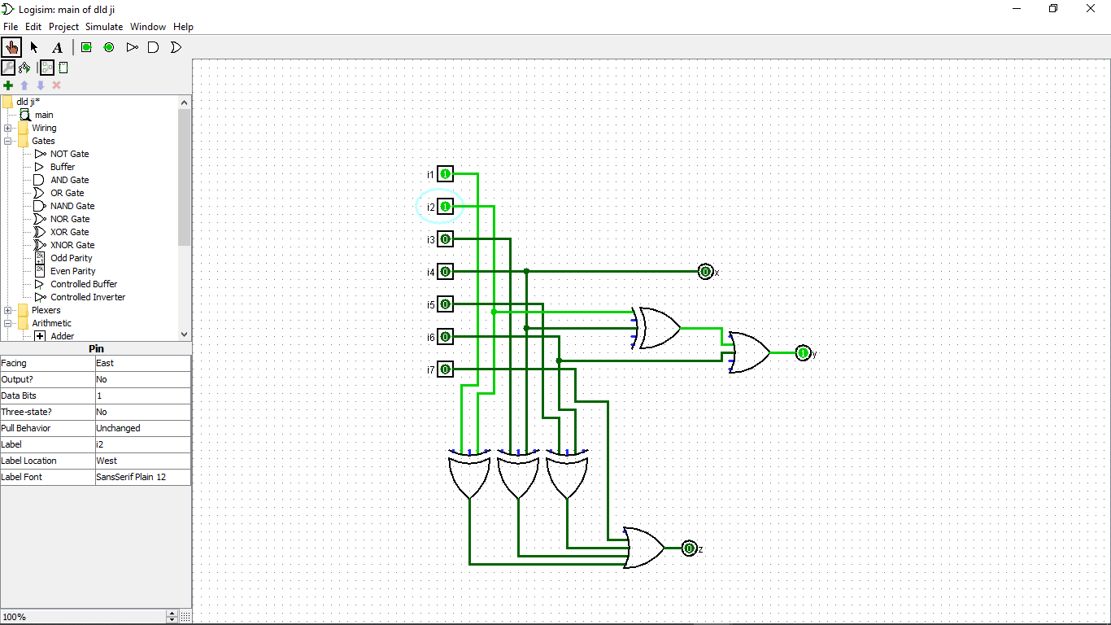

Only y=1 when there are 2 peoples.

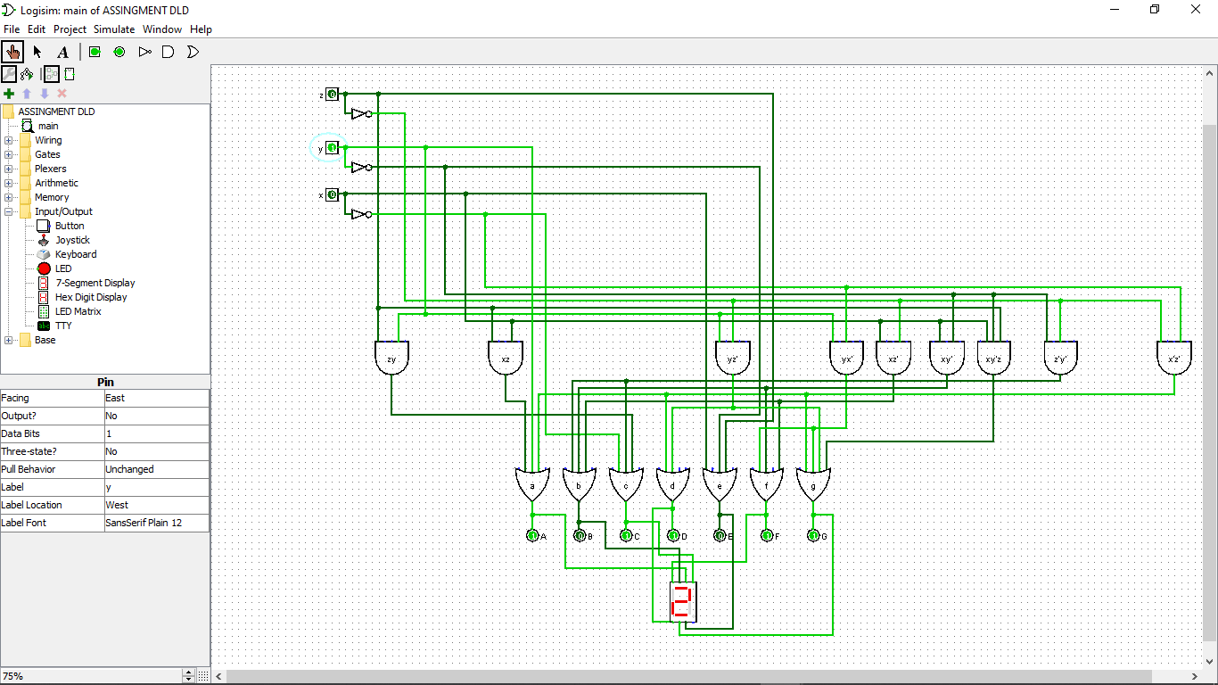

Other than b and e high and digital signage display 2.

1. 3 peoples.

When there is 3 people, i1, i2 and 13 will be high. The output for 3 bits binary is x=0, y=1 and z=1. For the output of 7-segment display, a=1, b=0, c=1, d=0, e=1, f=1 and g=1 to form 3. The verification using Logisim is as below:

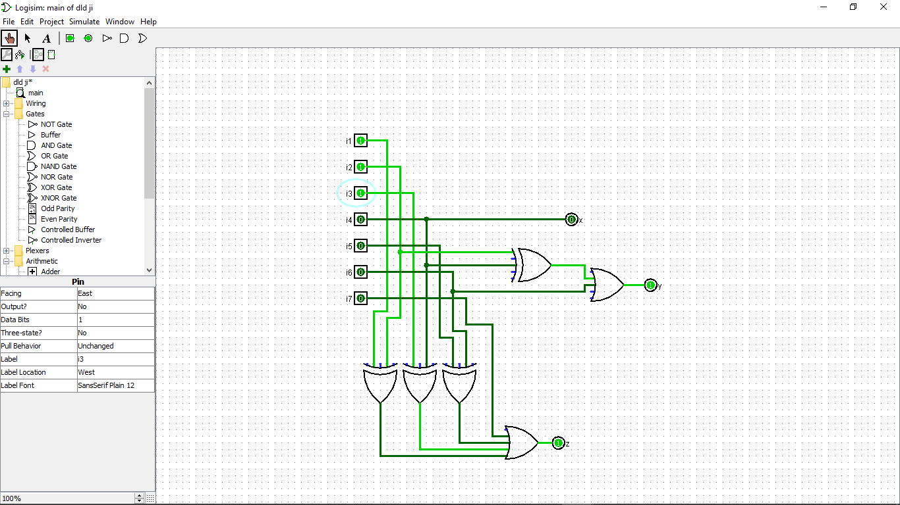

Z and y equal to 1 when there are 3 peoples.

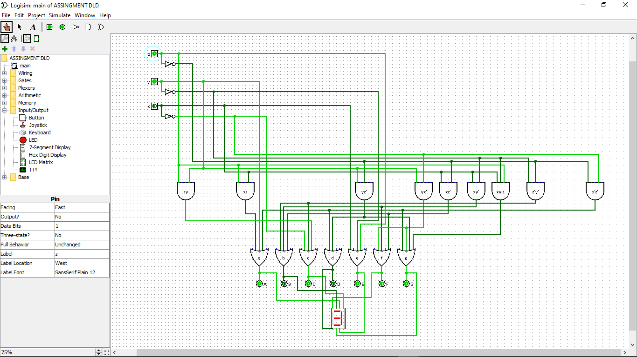

Other than b and d high, and the digital signage display 3.

1. 4 peoples.

When there is 4 people, i1, i2, 13 and i4 will be high. The output for 3 bits binary is x=1, y=0 and z=0. For the output of 7-segment display, a=0, b=1, c=1, d=0, e=1, f=1 and g=0 to form 3. The verification using Logisim is as below:

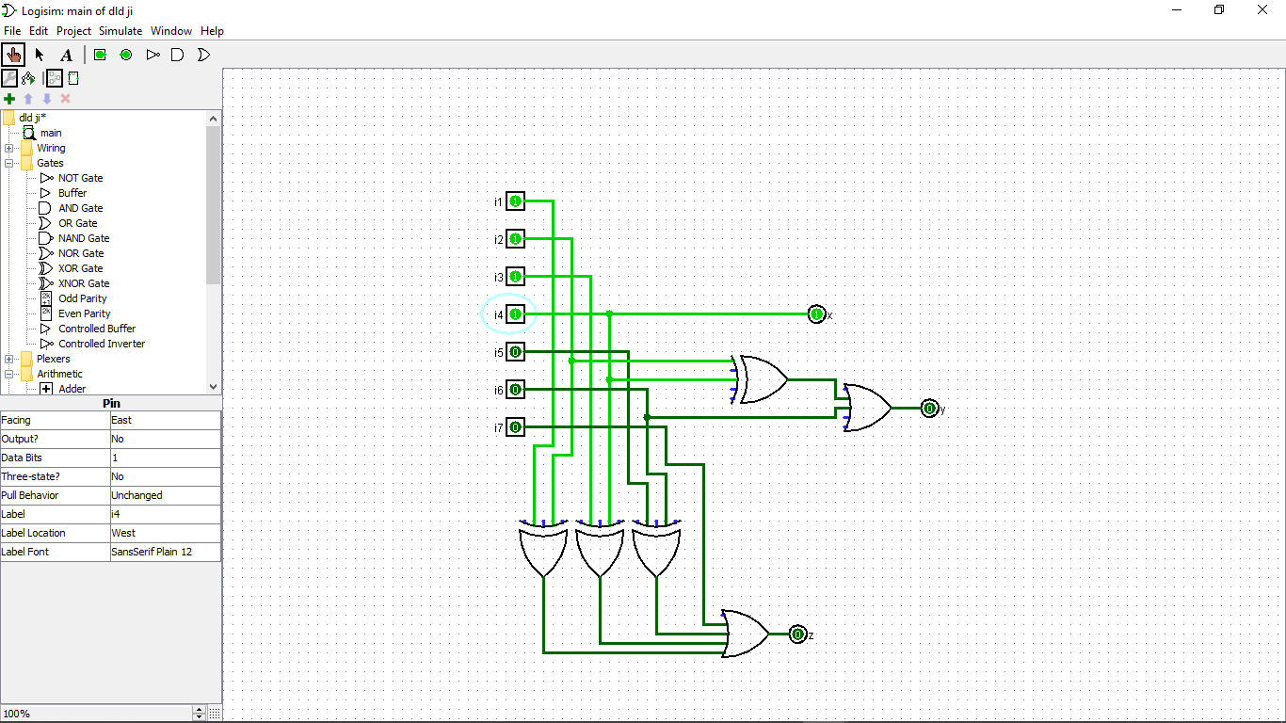

Only x equal to 1 when there are 4 peoples.

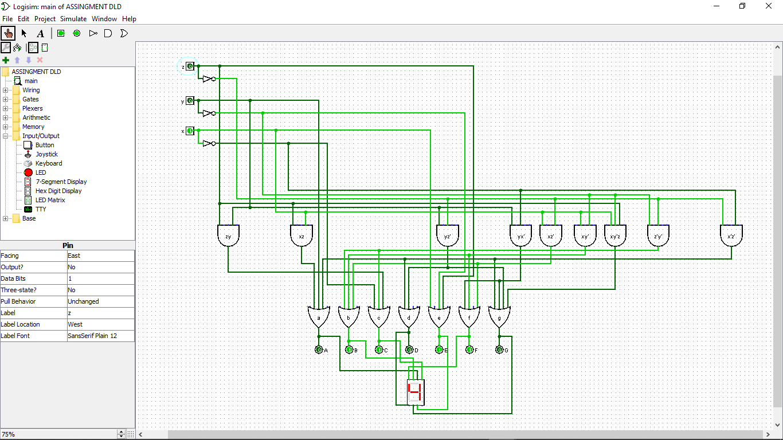

Other than a, d and g high, and the digital signage display 4.

1. 5 peoples.

When there is 5 people, i1, i2, 13, i4 and i5 will be high. The output for 3 bits binary is x=1, y=0 and z=1. For the output of 7-segment display, a=1, b=1, c=0, d=0, e=1, f=1 and g=1 to form 5. The verification using Logisim is as below:

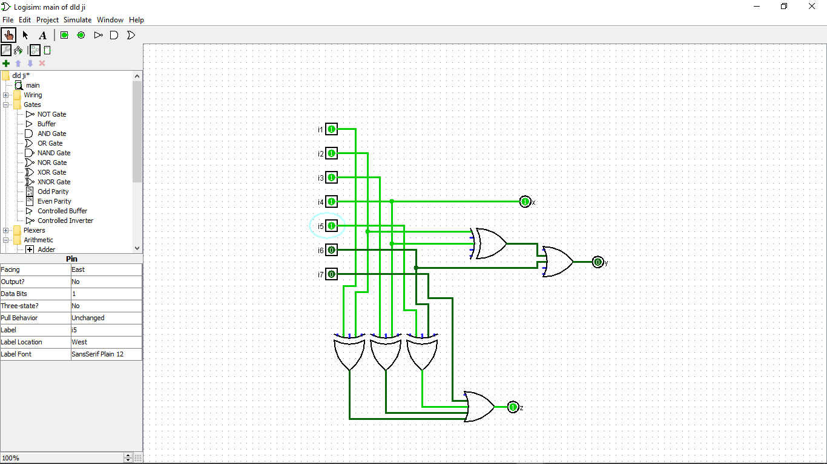

X and z equal to 1 when there are 5 peoples.

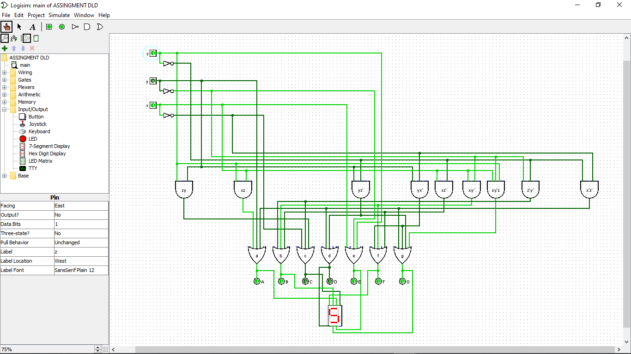

Other than c and d high, and the digital signage display 5.

1. 6 peoples.

When there is 6 people, i1, i2, 13, i4, i5 and i6 will be high. The output for 3 bits binary is x=1, y=1 and z=0. For the output of 7-segment display, a=1, b=1, c=0, d=1, e=1, f=1 and g=1 to form 6. The verification using Logisim is as below:

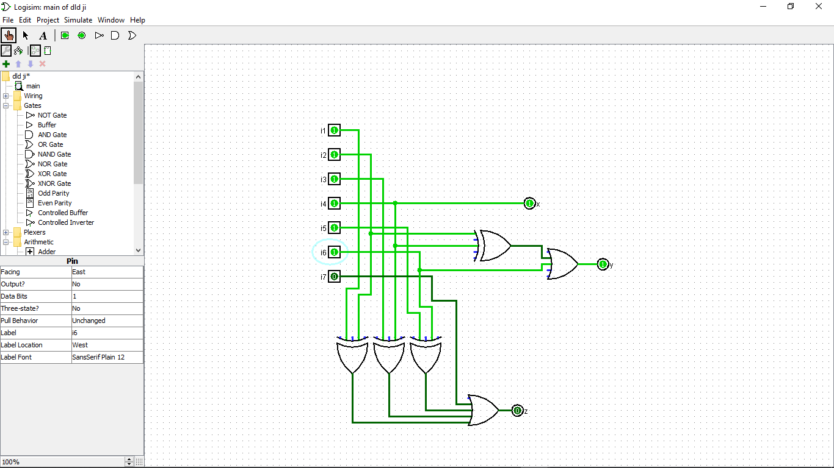

X and y equal to 1 when there are 6 peoples.

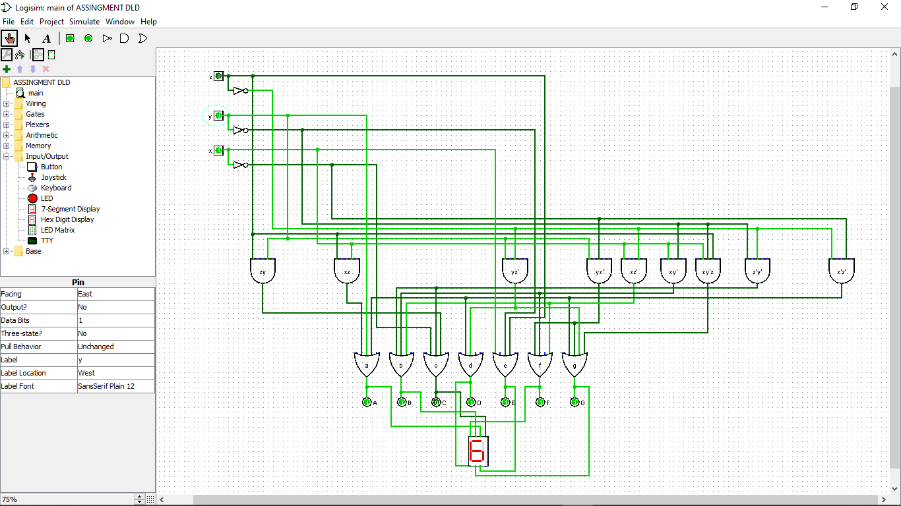

Other than c high and digital signage display 6.

1. 7 peoples.

When there is 7 people, i1, i2, 13, i4, i5, i6 and i7 will be high. The output for 3 bits binary is x=1, y=1 and z=1. For the output of 7-segment display, a=1, b=0, c=1, d=0, e=1, f=0 and g=0 to form 7. The verification using Logisim is as below:

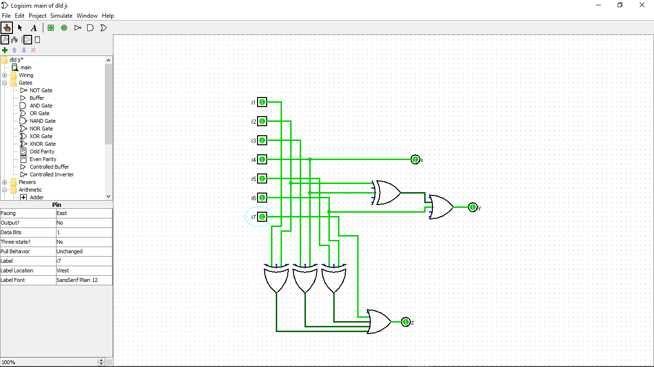

All x, y and z equal to 1 when there are 7 people.

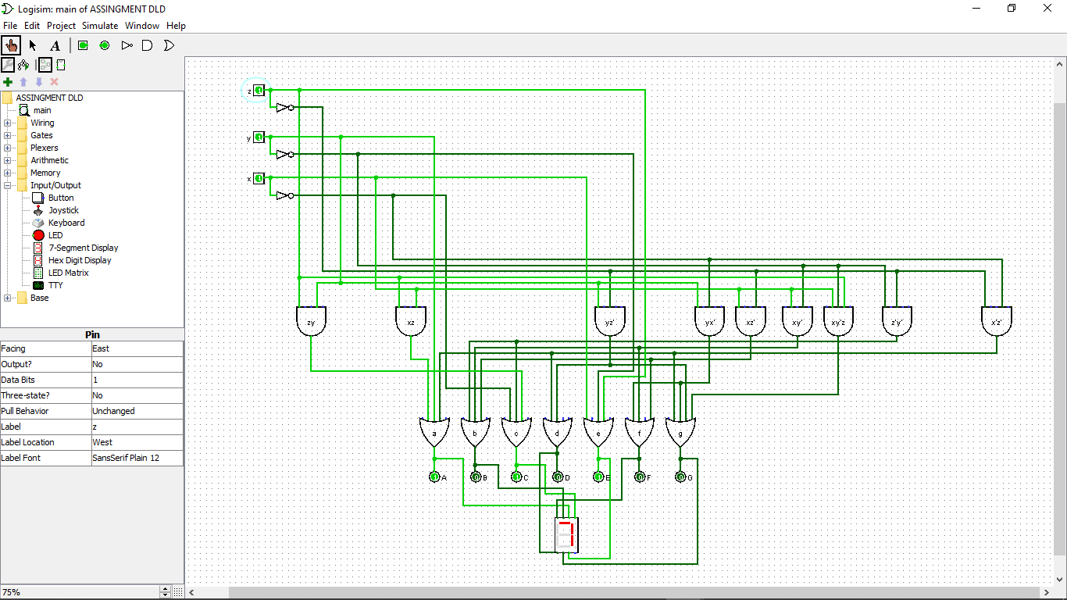

A, c and e high and the digital signage display 7.

**5. Conclusion.**

This system is built to ease the people coming to mosque to know how many places left in the mosque. The circuit is built by only used the logic gate with simple simplification by using what we have learn during our digital system design class such as truth table, Karnaugh map and Boolean expression with simplification using Boolean algebra. The circuit is functioning as it had been verified by using the Logisim.